# Limit Switches, Electronics Tray, and LCD Screen

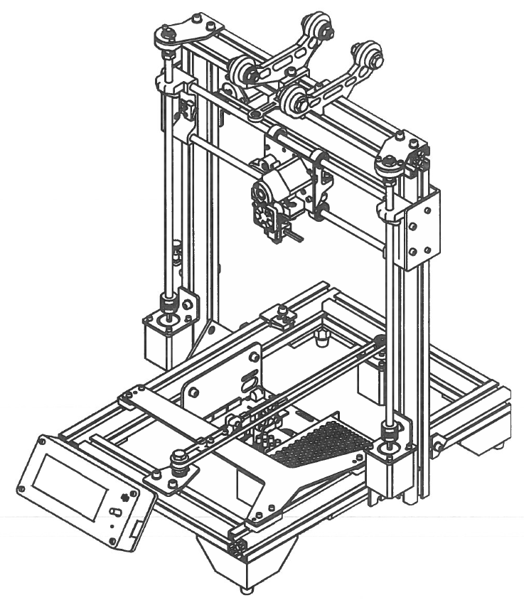

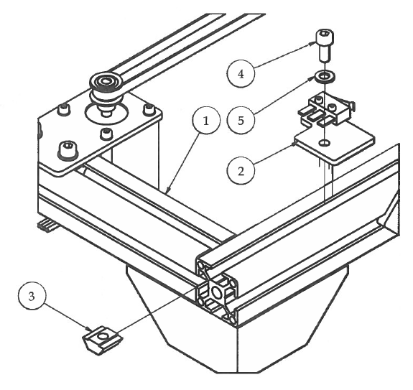Step 1

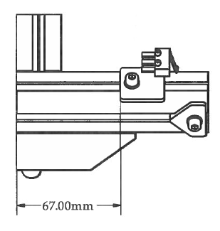

1. Attach the Y Limit Switch sub-assembly using M5 hardware.
2. The Y Limit Switch bracket 67mm from the back of the 3D printer.

|  |  |  |  |
| --- | --- | --- | --- |
| **PARTS LIST** | | | |
| **ITEM** | **QTY** | **PART NUMBER** | **DESCRIPTION** |
| 1 | 1 | X Stage Assembly | Previous sub-assembly |
| 2 | 1 | Y Limit Switch | Previous sub-assembly |
| 3 | 1 | M5 T-Nut | Nuts and bolts |
| 4 | 1 | M5 x 12 | Nuts and bolts |
| 5 | 1 | M5 Washer | Nuts and bolts |
|  |  | M4 Hex Wrench | Tools |

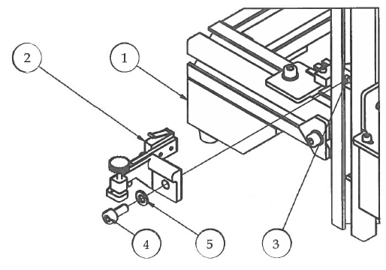Step 2

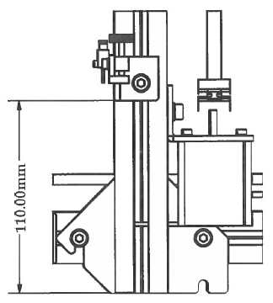

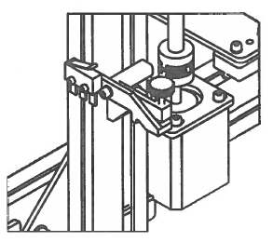

1. Slide M5 T-Nut into the outer slot of the left upright frame.
2. Attach Adjustable Z Limit Switch using M5 hardware measuring 110mm from the bottom of the extrusion. We will calibrate the position of this switch during the final calibration stage of assembly.

|  |  |  |  |
| --- | --- | --- | --- |
| **PARTS LIST** | | | |
| **ITEM** | **QTY** | **PART NUMBER** | **DESCRIPTION** |
| 1 | 1 | Step1 | Previous sub-assembly |
| 2 | 1 | Adjustable Z Limit Switch | Nuts and bolts |
| 3 | 1 | M5 T-Nut | Nuts and bolts |
| 4 | 1 | M5 x 12 | Nuts and bolts |
| 5 | 1 | M5 Washer | Nuts and bolts |
|  |  | M4 Hex Wrench | Tools |

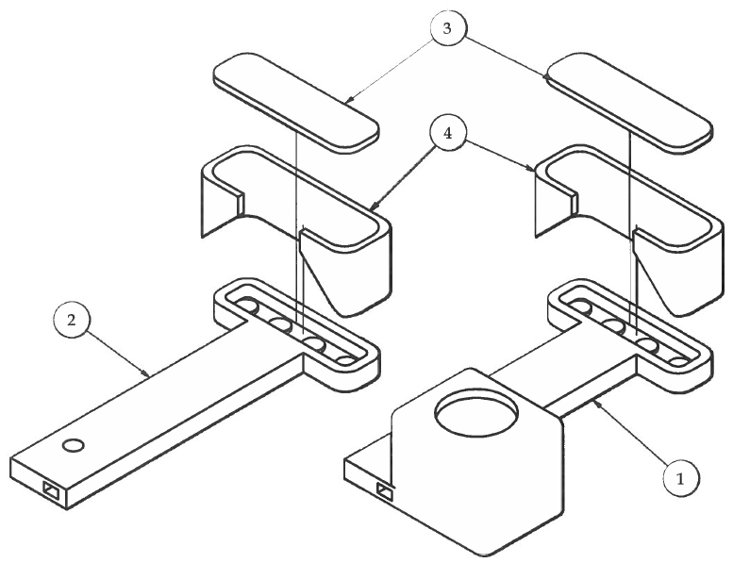Step 3

1. Press fit the LED lights into the LED light fixtures and solder them in a series circuit.
2. Solder wires to the LED light series circuits and run the wires through the small tubes inside the light post. (See "Super Bright 3D Printer Lights" on Thingiverse.com for detailed electrical assembly instructions).
3. Carefully attach the ledShade around the LED lights on each of the ledPost sub-assemblies. Leave about 2mm of the back side of the ledShade sticking out.
4. Snap in the ledCover plate on the back of the ledShade to cover the solder joints from the LED lights.

|  |  |  |  |
| --- | --- | --- | --- |
| **PARTS LIST** | | | |
| **ITEM** | **QTY** | **PART NUMBER** | **DESCRIPTION** |
| 1 | 1 | ledPostSwitch | Previous sub-assembly |
| 2 | 1 | ledPost | Previous sub-assembly |
| 3 | 2 | ledCover | 3D printed parts |
| 4 | 2 | ledShade | 3D printed parts |

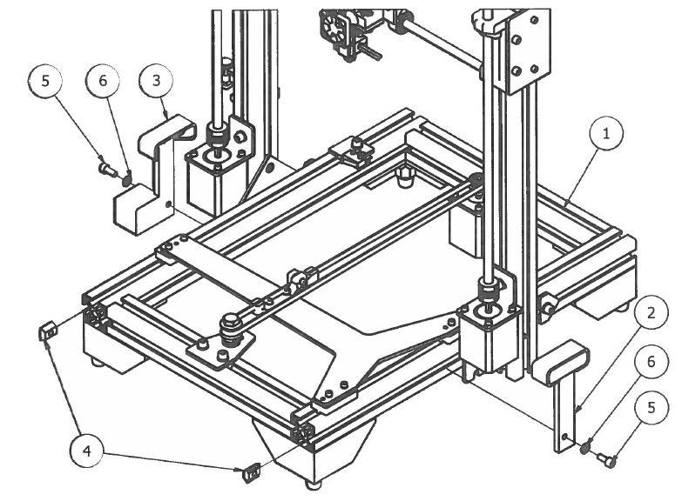Step 4

1. Attach both LED light fixtures to the bottom frame by sliding the LED light fixtures up against the Z motor brackets and attach using T-Nuts and M5 hardware.

|  |  |  |  |
| --- | --- | --- | --- |
| **PARTS LIST** | | | |
| **ITEM** | **QTY** | **PART NUMBER** | **DESCRIPTION** |
| 1 | 1 | Step1 | Previous sub-assembly |
| 2 | 1 | LEDpostAssy | Previous sub-assembly |
| 3 | 1 | LEDpostSwitchAssy | Previous sub-assembly |
| 4 | 2 | M5 T-Nut | Nuts and bolts |
| 5 | 2 | M5 x 12 | Nuts and bolts |
| 6 | 2 | M5 Washer | Nuts and bolts |
|  |  | M4 Hex Wrench | Tools |

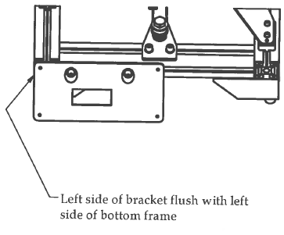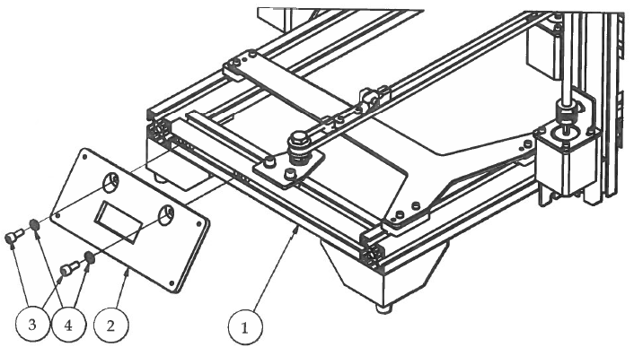Step 3

1. Attach the LCDpanelBoxBack to the font of the bottom frame using the existing T-Nuts and M5 hardware.
2. Make sure the left-outside of the bracket is flush with the left side of the bottom frame. This allows sufficient space when folding the crossbar down for shipping and/or transportation.

Left side of bracket flush with left side of bottom frame

|  |  |  |  |
| --- | --- | --- | --- |
| **PARTS LIST** | | | |
| **ITEM** | **QTY** | **PART NUMBER** | **DESCRIPTION** |
| 1 | 1 | Step2 | Previous sub-assembly |
| 2 | 1 | LCDpanelBoxBack | 3D printed parts |
| 3 | 2 | M5 x 12 | Nuts and bolts |
| 4 | 2 | M5 Washer | Nuts and bolts |
|  |  | M4 Hex Wrench | Tools |

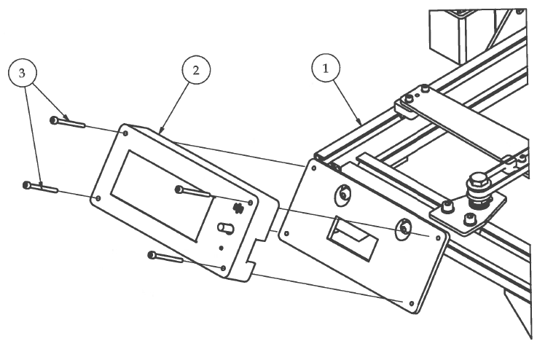Step 4

1. Attach the LCDscreenPanelBoxFront using M3 hardware. The M3 x 40 bolts will self-tap into the LCD Back Panel.
2. Make sure that the AC Power Switch is oriented in the correct position and that all of the wires to the LCD screen and AC power switch are placed through the rectangular window on the LCDscreenPanelBoxBack bracket before securing in place.

|  |  |  |  |
| --- | --- | --- | --- |
| **PARTS LIST** | | | |
| **ITEM** | **QTY** | **PART NUMBER** | **DESCRIPTION** |
| 1 | 1 | Step3 | Previous sub-assembly |
| 2 | 1 | LCDscreenSubAssembly | Previous sub-assembly |
| 3 | 4 | M3 x 40 | Nuts and bolts |
|  |  | M2.5 Hex Wrench | Tools |

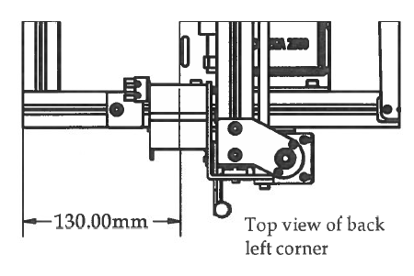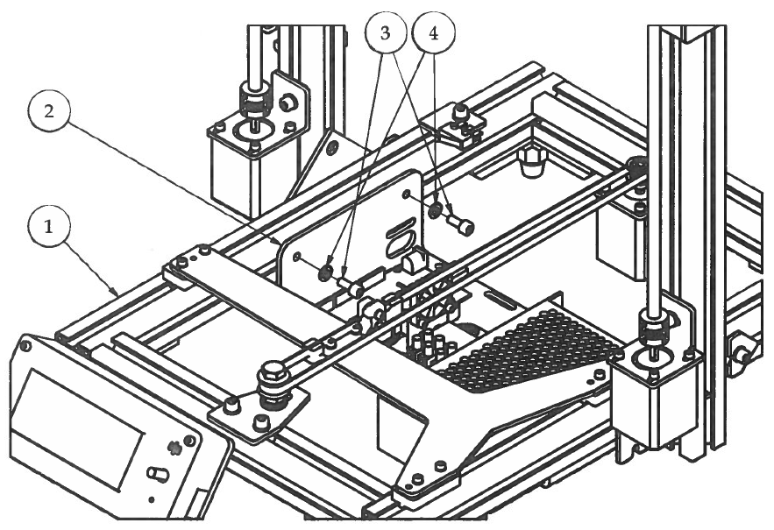Step 5

1. Attach the Electronics Tray sub-assembly to the bottom frame using the existing T-Nuts on the inside left and right slots and M5 hardware.
2. Measure 130mm from the back of the Electronics Tray to the back of the bottom frame.

Top view of back left corner

1. Secure in place.

|  |  |  |  |
| --- | --- | --- | --- |
| **PARTS LIST** | | | |
| **ITEM** | **QTY** | **PART NUMBER** | **DESCRIPTION** |
| 1 | 1 | Step4 | Previous sub-assembly |
| 2 | 1 | ElectronicsTraySubAssembly | Previous sub-assembly |
| 3 | 4 | M5 x 12 | Nuts and bolts |
| 4 | 4 | M5 Washer | Nuts and bolts |
|  |  | M4 Hex Wrench | Tools |

# Electrical Assembly

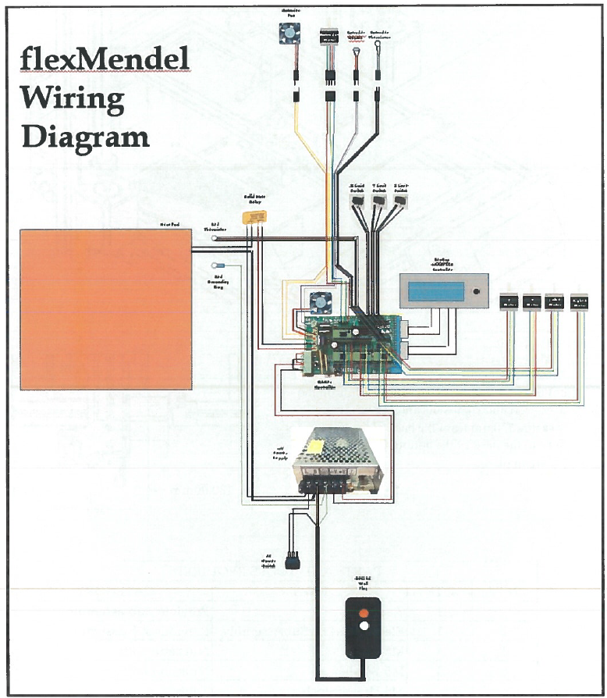

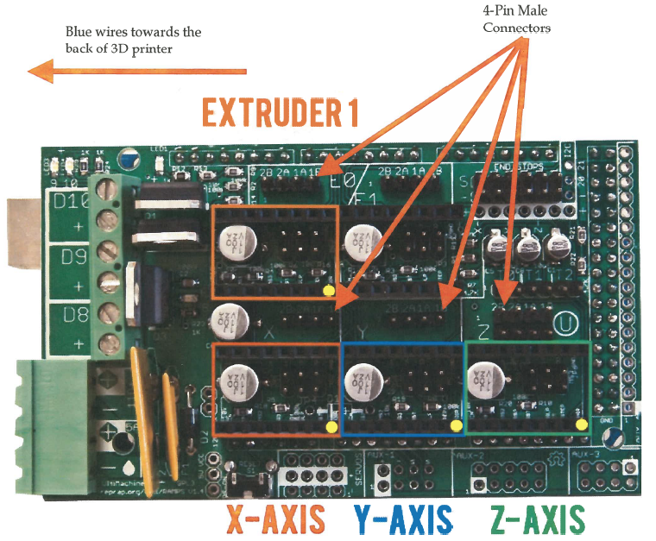

4-Pin Male Connectors

Blue wires towards the back of 3D printer

1. Plug X, Y, LZ, RZ and Extruder Motor wires into the 4-pin male connectors next to the appropriate stepper drivers. All motor wire plugs should have the BLUE WIRE TO THE BACK of the printer.

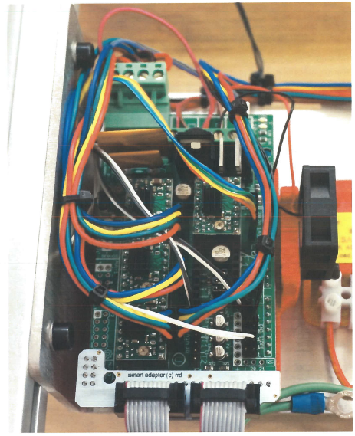RAMPs Magnified

1. Limit Switches are plugged into X-, Y-, and Z-
2. D8 Terminal is for heated bed signal wire that goes to the SS Relay
3. D9 Terminal is for both fans, RAMPs and Extruder Fans. Make sure that the RED wires get plugged into the POSITIVE (+) port.
4. D10 Terminal is Extruder Heater
5. T0 is for Extruder Thermistor
6. T1 is for Bed Thermistor
7. DC Power Input must have jumper wires in correct ports!

DC Power Supply Magnified

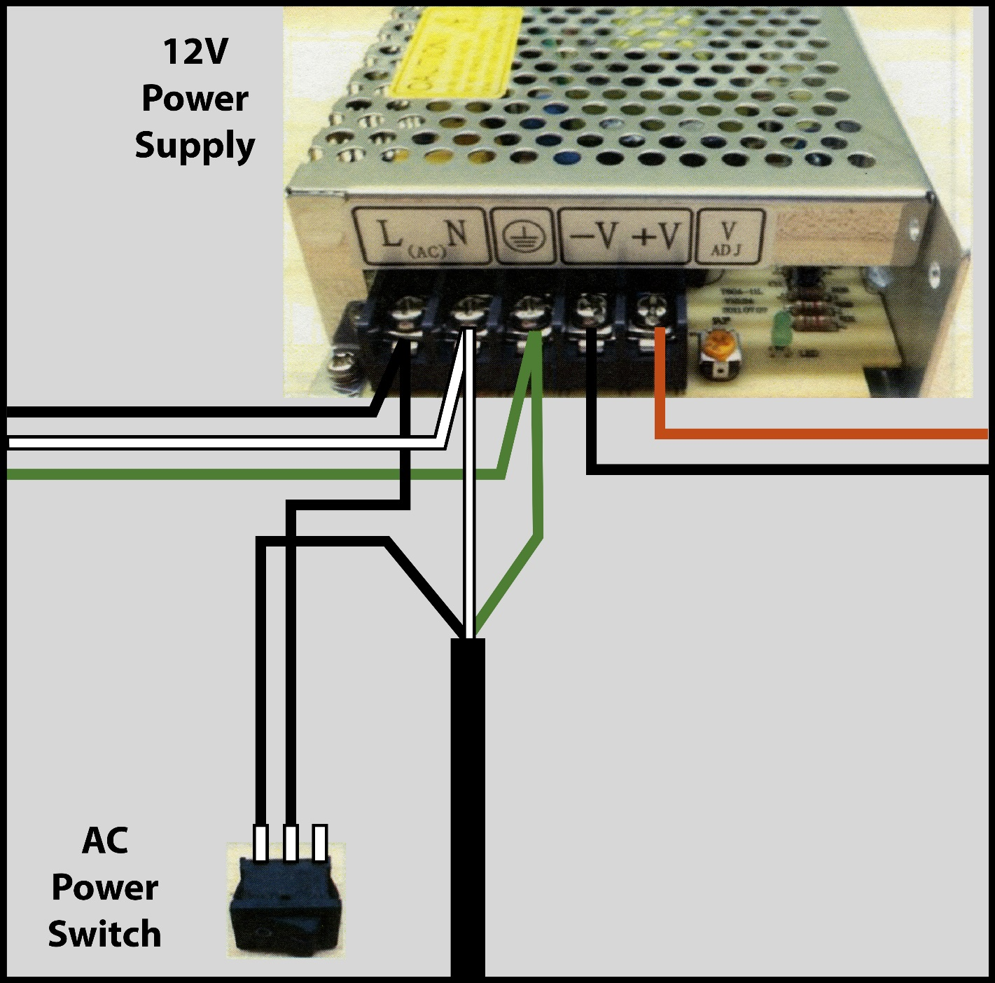

Heated Bed Magnified

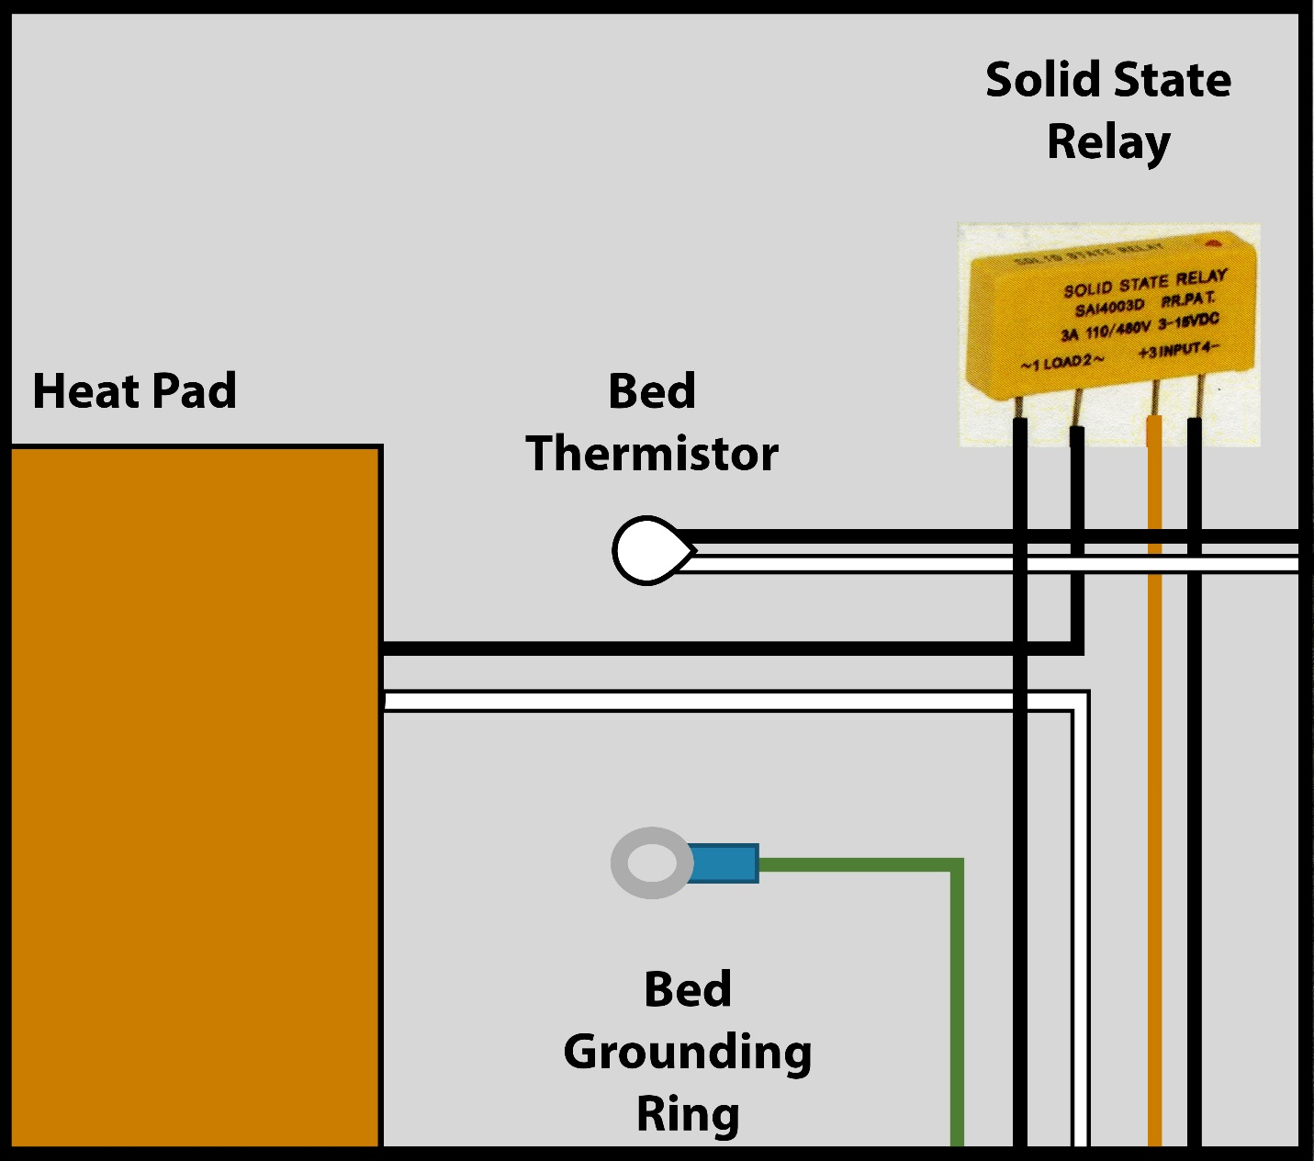

* Solid State Relay will have Euro-style connector to easily attach wires
* Bed Grounding Ring should be wired into the ground terminal on the power supply. This ensures that the entire frame is grounded.

# Heated Bed Assembly

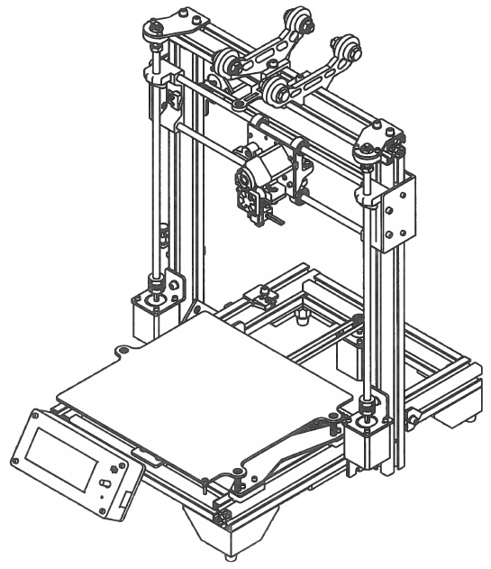

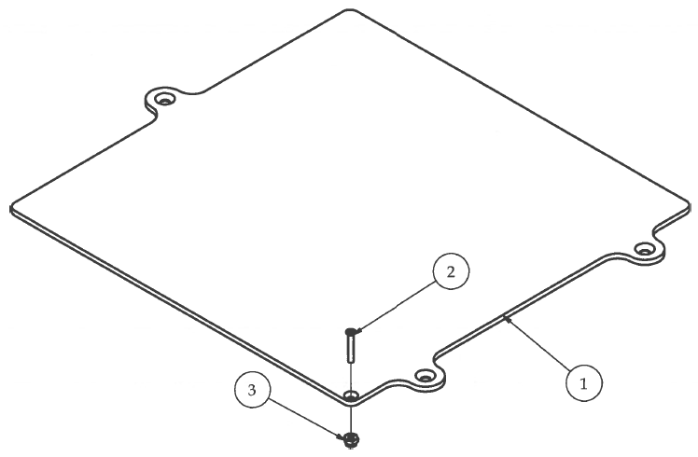Step 1

1. Secure the wire strain relief post to the Bedplate using #4 hardware.

|  |  |  |  |
| --- | --- | --- | --- |
| **PARTS LIST** | | | |
| **ITEM** | **QTY** | **PART NUMBER** | **DESCRIPTION** |
| 1 | 1 | bedPlate V2_AL | Custom aluminum part |
| 2 | 1 | #4 x 3/4" Machine Screw | Nuts and bolts |
| 3 | 1 | #4 Nylock Nut | Nuts and bolts |

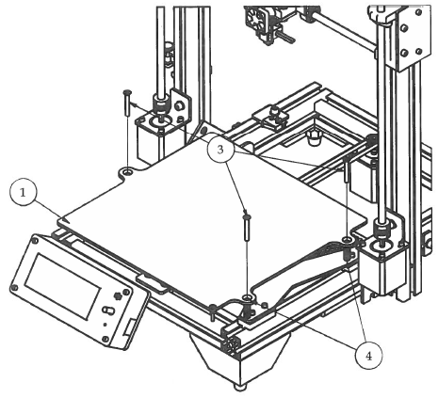Step 2

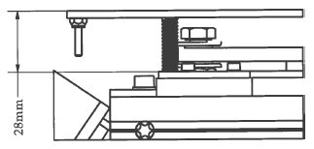

1. Attach the Bedplate sub-assembly to the Y Carriage using the Compression springs and the #8 hardware. DO NOT OVER TIGHTEN BEDSCREWS!!!
2. Using a precision ruler, measure 28mm from the top of the Y Carriage to the top of the Bedplate.

|  |  |  |  |
| --- | --- | --- | --- |
| **PARTS LIST** | | | |
| **ITEM** | **QTY** | **PART NUMBER** | **DESCRIPTION** |
| 1 | 1 | LimitSwitchesLCDpanelElectronicsTrayAssembly | Previous sub-assembly |
| 2 | 3 | #8 x 1 1/4" Machine Screw | Nuts and bolts |
| 3 | 3 | Compression Spring | Off-the-shelf components |
| 4 | 1 | Step1.1 |  |

Congratulations!!! You have finished building the flexMendel 3D printer!!!

Now it is time for calibration and then... TIME TO PRINT!!!

**Open Source flexMendel link:**

**Original designer and creator: Dave Kennell**

**Updated version OSC flex 1: Rob Martin**

**Open Source flexMendel: http://www.thingiverse.com/thing:251227**

# Mechanical Systems Test

Motor Jog Test:

**X Motor Jog** - Click on Encoder → Prepare → Move Axis → X-Axis and turn the knob to the right. X+ should move the extruder to the right, X- should move the extruder to the left

**Y Motor Jog** - Click on Encoder → Prepare → Move Axis → Y-Axis and turn the knob to the right. Y+ should move the bedplate to the front, Y- should move the bedplate to the back

**Z Motor Jog** - Click on Encoder → Prepare → Move Axis → Z-Axis and turn the knob to the right. Z+ should move the Z axis up, Z- should move the Z axis down

Check the locations of the limit switches to ensure the action is clear

Calibrating the positions of Y and Z Limit Switches:

**Set Y Limit Switch** - Loosen the M5 bolt that attaches the Y Limit Switch Bracket to the bottom frame. Slide the bed all the way to the back of the Y axis until it makes contact with the stepper pulley. Move the bed forward about 2mm. Slide the Y Limit Switch Bracket forward until the limit switch makes contact with the Y Carriage and clicks. Tighten the M5 bolt on the Limit Switch Bracket and you're set!

**Set Adjustable Z Limit Switch** - Adjustable Z Limit switch should be moved to the appropriate position so that the M3 x 20mm screw is centered in position after the Z axis is homed and the tip of the nozzle sits 0.3mm above the glass. See the "Bed Leveling" section of this manual for more detailed instructions on how to calibrate the Adjustable Z Limit Switch.

**Home All Axes** - Click on Encoder → Prepare → Auto Home → You should notice the flexMendel "Homing" each axis, X, Y, Z, respectively.

Check the Heating and Cooling Components:

**Heating Elements Check** - Double check your Hot End and make sure that none of the extruder wires are touching any part of the Hot End before proceeding to the next step.

**To Preheat the flexMendel - Click on Encoder → Prepare → Preheat PLA**

Go back to the home screen on the LCD Smart Controller. You should see the temperatures in both the upper-left and upper-right corners on the screen increasing. **DO NOT TOUCH THE HOTEND OR THE HEATED BED!!!**

**Heated Bed** - After selecting Preheat PLA and returning to the home screen of the LCD Smart Controller, you should see different numbers in the upper left and right corners of the screen. The upper-left corner shows the temperature of the hotend (Actual Temp/ Set Temp) and the upper­ right corner shows the bed temperature (Actual Temp/ Set Temp). Both temperatures should be rising fairly quickly at this point. Make sure that the heated bed reaches the pre-set temperature and then stops heating. It may rise a few degrees above the set temperature, but will slowly fall. If the bed temperature rises to 10 degrees above the set temperature, turn the 3D printer off and check the thermistor wires where they plug into the RAMPs. It could be a possibility that you might have gotten the hotend thermistor and the bed thermistor mixed up.

**Hot End** - When you first turn on your Hot End, you may notice a little bit of smoke that escapes from the heater cartridge. This is normal and should only last a few seconds or so.

**Extruder Motor** - As a safety precaution, the flexMendel will not allow the Extruder motor to extrude unless the Hotend has been preheated to a minimum of 170° Celsius. Make sure Hotend is preheated.

**Click on Encoder → Prepare → Move Axis → Extrude**

If the filament shaft turns **COUNTERCLOCKWISE**, you have it hooked up correctly. If it is spinning clockwise then reverse your extruder motor wire plug on the RAMPs Shield.

**Turning Off Heating Elements** -This will turn off all heating elements on the flexMendel 3D printer.

**Click on Encoder → Prepare → Cooldown**

**Fans Check** - Turn on the fans will help cool down the heating elements faster. You will want to check to make sure that both fans, Extruder fan and RAMPs shield fan, are running. If either of the fans fail to operate, overheating of either the Hot End or the RAMPs shield can cause serious damage to your flexMendel 3D printer.

**Click on Encoder → Control → Temperature →Fan Speed → Turn up to 255 → Click Encoder.**

To turn the fans off, simply reverse the above instruction.

Mechanical Systems Check Complete!!! If all systems are functioning properly, move onto the next step.

# Setting up the flexMendel in the Classroom

**Physical Location of the 3D Printer**

Selecting a room for a 3D printer is important for optimal operation. The room needs to provide a controlled environment to minimize potential problems that could affect the operation of the 3D printer and the quality of the parts being printed.

The room should provide:

* An area free of dust from other technical activities (i.e. saw dust, construction material debris, metal chips or flakes, etc.),
* Proper ventilation and temperature control (between 70-80° F or 21-27° C),
* Steady and reliable source of electricity to power the 3D printer,
* A sturdy desk or workbench that the 3D printer can either be placed or mounted on, and
* An area away from HVAC vents and open windows to prevent air drafts from interfering with the 3D printing process.

The next step in setting up an optimum environment is to make sure that the desk or workbench is level for the 3D printer. The table or workbench should be sturdy and not have a wobbly leg. 3D printers move rapidly during operation, so they tend to vibrate whatever work surface they are sitting on. If the workbench is not sturdy and allows for excessive vibration, this extra movement can transfer to the finish quality of the 3D printed part, and you will be able to visually see imperfections on the surface of the part due to excessive vibration.

**Theft Prevention**

This section is to caution teachers that it is possible for a 3D printer to be stolen from the classroom. 3D printers are small and easily portable. They can be placed into a box or even a book bag in a matter of seconds, and some precautions should be made to prevent theft of the 3D printer. There are several things that can be done to prevent this from happening. 3D printers can easily be mounted to the workbench they are housed on, thus making it much more difficult to be stolen. They can also be locked up using a bike lock that is attached to the work bench or table. Another method for preventing theft is to place the 3D printer on a movable cart and simply move the cart to a room or closet that can be locked to prevent theft from occurring. This may seem a bit much, but there would be nothing worse than to have a class project be ruined by the disappearance of the 3D printer in the middle of the school semester

# Bedplate Leveling

This is one of the most important skills that a 3D printer operator will need to have because the first layer of a printed object determines all subsequent layers of that object. It also needs to be noted that with all types of 3D printers, the bed-leveling process may have a slightly different mechanical setup. This exercise is assuming that the 3D printer was assembled properly and the Z-limit switch is set at the appropriate height. If not, please refer to the manufacturer's directions of how to set the Z-limit switch.

We will examine three different mechanical setups, but the overall goal of leveling the bedplate is of the same importance with any 3D printer. Three points is the minimum number of points required to define a two dimensional plane. Most bedplates on 3D printers have three screws that • allow for the adjustment of the bedplate (X Y plane). The location of these three screws can vary depending on the 3D printer, but there are common characteristics of the bed-leveling screw positions. Two of the screws will be aligned on a single axis, either the X or the Y, and then the third screw is centered between the other two and offset a certain distance from the first two Screws.

Three different bedplate leveling screw positions for popular 3D printers are shown below. The black dots represent the position of the three adjustment screws for leveling the bedplate. It is also important to understand that the distance between the bed-leveling screws also plays a part in determining the difficulty in leveling the bed. This makes sense if you think about it. The closer together the bed-leveling screws are, the harder it will be to get the bed level because even the tiniest of adjustments will move the bedplate considerable distances. If the bed-leveling screws are placed far apart like the open-source flexMendel 3D printer, then making minor adjustments only moves the bedplate a minimum distance, thus giving the operator much more precise control when leveling the bedplate. Look at the diagrams below and identify the bed-leveling screws and their respective axis they lie on.

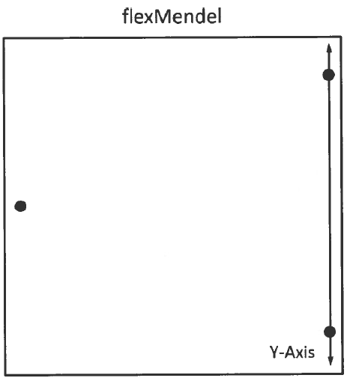

The first step in leveling the bed is to identify where the two adjustment screws are that align with either the X or Y-axis; these two screws should be leveled first with the tip of the extruder before moving on to the final adjustment screw. **When these two measuring points have been leveled**, they will remain level on their respective axis while adjusting the third and final adjustment screw because of the location of the screws.

**\*\*\* CAUTION\*\*\***

There is not much difference between electric motors and electric generators. Even when the 3D printer is turned off, the stepper motors can generate electricity if the extruder or bedplate are moved around too quickly. This will cause an electric current to flow backwards through the wires on the machine and can easily damage fragile electrical components on the 3D printer controller. Most electrical components on the circuit board are designed to respect polarity (hooking the positive and negative leads in a specific direction). When moving either the extruder or the bedplate, move them SLOWLY to not generate a surge of electricity that could damage the 3D printer's controller. Controller cost around $200 to replace.

**\*\*\* CAUTION \*\*\***

To begin the bed-leveling process, move the extruder so that the tip of the extruder is either on the imaginary line created by the first two adjustment screws or as close as possible to that line. Then move the bed so that the extruder is as far to one side of the bed as possible. See the black square with number 1 on the bedplate in the image on the next page for suggestive extruder starting locations.

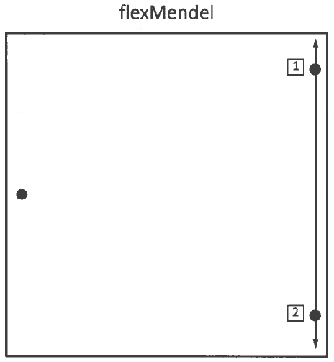

Place the piece of paper or the 0.25 mm feeler gauge between the tip of the extruder and the bedplate. If you cannot fit the feeler gauge in between the extruder and the bedplate or if there is a gap between the feeler gauge and the extruder, you will need to make some adjustments. Turn the adjustment screw closest to the extruder until the feeler gauge has friction from both the extruder and the bedplate. Be careful that the bedplate is not being pressed down on the springs when performing this exercise.

Move the bedplate or the extruder to the opposite end of the imaginary line described on the last page where the black box has a number 2 and repeat the leveling process described above. When you have completed this second leveling point, move the bedplate or extruder back to the original measuring point and recheck the distance with the feeler gauge. Make any adjustments as necessary, and then check the second measuring point again.

Move the bedplate or extruder so that the contact point is close to the edge of the bedplate by the third and final adjustment screw. Repeat the leveling process. Then move the bedplate or extruder so the contact point is on the opposite side of the bedplate, along the same respective axis.

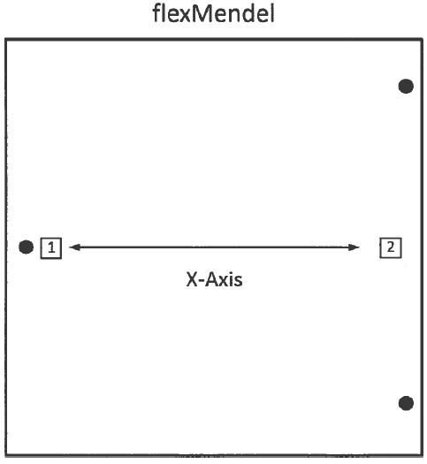

After completing all of the bed-leveling exercises, it is a good habit to move the extruder around all edges of the bedplate and check that the space between the extruder and bedplate is 0.25 mm.

The 3D printer should now be set up in an optimal environment for operation and mechanically calibrated to produce high quality printed parts.

# The Critical 1st Layer

The first layer of every object created using a 3D printer is always the most critical layer. Without good adhesion to the bedplate, the part has little chance of being created with the intended precision.

Although 3D printers are quickly becoming more reliable, during the first print layer, the operator needs to carefully inspect the machine's activity. Beyond the first layer, carefully watching the machine is not as critical. Most 3D printers extrude plastic material in layers that are around 0.3 mm thick. Leveling the bedplate to make the extruder nozzle parallel with the bedplate at a 0.3 mm height covering an area that is 200 mm x 200 mm or more is not an easy task. This is similar to trying to have a machine stay exactly 6 feet off the ground for the length of an entire football field.

With a little practice, the operator should be able to check the quality of the first layer with only a glance or two. They might need to make a few small adjustments to the 3D printer, but eventually these skills will become second nature.

Many things can happen during the first layer that can ruin a part. If the nozzle is too close or pressing against the bedplate on the first layer, it can prevent plastic from flowing out of the orifice, meanwhile new plastic continues to be forced into the extruder. This causes a back flow of plastic, and eventually the molten plastic will come out of the top of the extruder or force its way down the threads that attach the nozzle. If either of these things happen, the chances are high that the extruder has just been ruined, which would result in the user having to purchase a new one for around $60-$80.

The other extreme is with the tip of the extruder being too far away from the bedplate so that the plastic will to stick to the mirror. Although this may seem ok at first glance, later in the print, the part will begin to curl up its corners and eventually become detached from the bedplate. If the part is no longer attached to the bedplate, the machine's precision becomes worthless as it extrudes plastic into midair like spaghetti. The part is now ruined, and the time and money invested in printing this part is wasted. On the next page is a diagram that shows a profile view of various first layer heights.

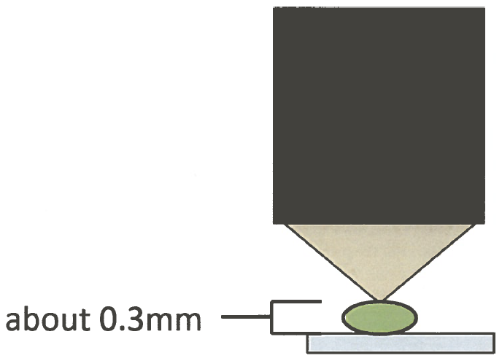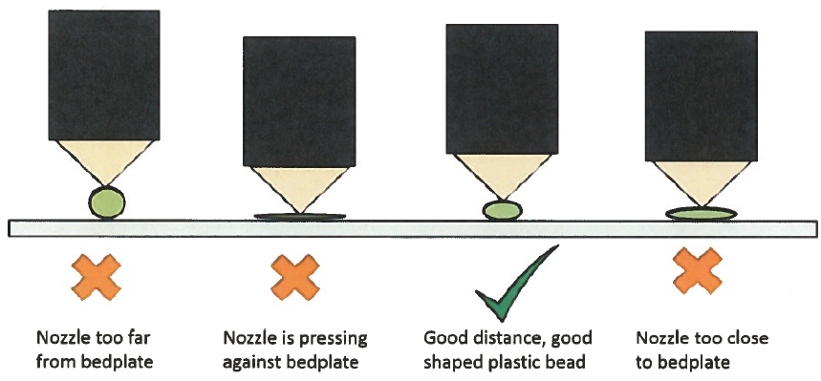

With the layer heights extruded from 3D printers being so tiny, you might ask, what is the best way to make sure the height is at the correct distance? Lots of companies insist that using a piece of paper or a feeler gauge is the best way, but this is not always true. Tension to one person between the nozzle and the feeler gauge could be interpreted differently to another. The best way is look at the bead of plastic that is being extruded from the nozzle. The best time to watch this bead of plastic is when the machine is creating the "skirt" (the first perimeter around the part). The operator should be able to see the size of the bead of plastic and judge whether it is too close or too far from the bedplate. With many open-source 3D printers, you can adjust the Z height on the fly, which truly allows every print the opportunity to be calibrated correctly while in motion. Many commercial printers have mechanical setups that do not allow for Z-height adjustment while in motion. This means that if the operator notices an incorrect height, the print must be stopped in order for the machine to be adjusted. In either situation, remember to take great care in watching the first layer of the print because it is a significant indicator as to whether the machine is going to continue making the part with no problems or if there is potential for a misprint.

# flexMendel Operation RepRap Smart LCD Controller

The most popular open source 3D printer interface controller is the RepRap Smart LCD Controller. This controller completely frees the operator from having to connect the 3D printer to a computer at all. The RepRap Smart LCD Controller sells for around $50 and comes complete with hookup wires and pin attachment clips, an LCD screen, a click encoder for menu navigation, a SD card slot, and even a buzzer alarm that can be used to notify the operator of various functions within the 3D printer. It is extremely affordable and offers the user many great functions that are not available on some commercial 3D printers.

It is extremely easy to use and offers expanded functionality for the operator when calibrating the 3D printer or while it is in operation. This is very handy for times when calibration of the 3D printer needs to be made on the fly while the machine is in motion. In the following pages is the complete RepRap Smart LCD Controller Menu Map, followed by Menu Option explanations and the 3D printing procedure and on-the-fly calibrations that can be made using this interface technology.

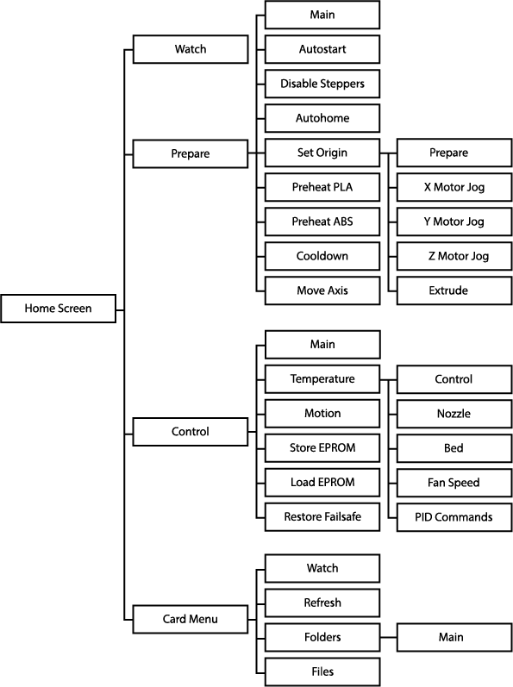RepRap Smart LCD Controller Menu Map:

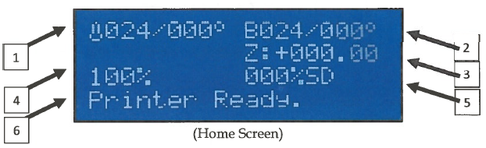Home Screen Display:

1. *Nozzle Temperature* - (Current temp/Set temp)
2. *Bedplate Temperature* - (Current temp/Set temp)
3. *Z Height* - (Measured in millimeters from home Z position)
4. *Machine Speed* Percentage - Can be turned up or down.
5. *% of SD File Completion* - An indicator of how much of the G-code file has been completed.

To Print a File from the SD card:

1. 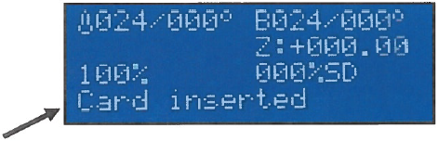Insert SD card with G-code file to print
2. 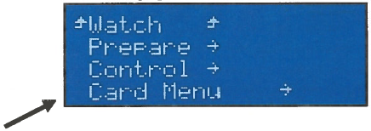Click the Encoder knob to bring up the Main Menu.
3. Turn the Encoder knob to scroll down to "Card Menu" and click the encoder.
4. Turn the Encoder knob to scroll down and find the G-code file that you want to print. Depending on how the files are organized on the SD card, there might be folders on the card that contain specific project G-code files. You can click on a folder to open it and see the files inside. When you locate the file that you want to print, click the encoder to select that file.

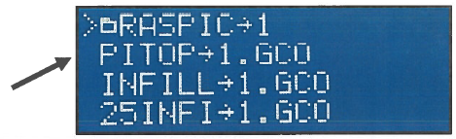

3D Printer calibration settings that can be changed on-the-fly:

1. Speed of the 3D Printer
   1. While at the home screen, simply rotate the encoder clockwise to increase speed percentage and counterclockwise to decrease speed percentage.
2. Nozzle or Bed Temperature and/or Fan Speed
   1. 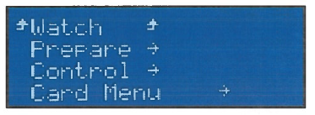Click the encoder to enter the Main Menu.
   2. Scroll down, and click on “Control.”

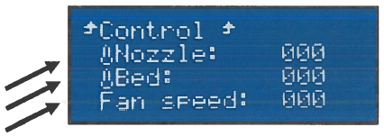

* 1. Scroll to either Nozzle, Bed, or Fan and click the encoder to enter change mode.
  2. When in change mode, simply rotate the encoder clockwise to increase temperature and/or speed, and turn counterclockwise to decrease temperature and/or speed percentage
  3. Click the encoder again to exit change mode.
  4. Scroll to the top and click on "Control" to go back to the Control screen.
  5. Click "Watch" to go back to the Home screen.

# Basic 3D Printer Operational Procedures

The basic process of operating a 3D printer is fairly simple. There are five major steps involved with using a 3D printer, and really only the last three steps are essential. The first two steps are optional because they assume that you are creating your own CAD model to be printed. The majority of 3D CAD models that are created using 3D printers were already created by someone else but are accessible through various open-source 3D printing websites like Thingiverse (www.thingiverse.com) or Instructables (www.instructables.com). In that case, all you would need to do is download the STL file, convert the STL file into a G-code, and then send it to the 3D printer to print. Below is a chart showing the basic 3D printer operational procedures.

1. If you are creating a new 3D model that you are going to print using the 3D printer, you will need to start by using some sort of 3D CAD modeling software to digitally develop the 3D model. Autodesk Inventor is the most popular 3D CAD modeling software in the educational system. There are also several open-source 3D CAD modeling software programs that are free and available on the Internet.
2. Once the 3D CAD model is complete, it is good practice to save the master file in a safe place for future reference. Often times, the user will need to make changes in the model after they print it out the first time and realize that some changes need to be made in order for the printed part to function optimally. In order to move to the next phase, you will need to "Export" the 3D CAD model into an STL file format. The STL file is necessary to send through the G-code file generator.
3. The next part of the process is where many people using 3D printers will start. They will need to obtain the STL file of the part that they wish to print. This is relatively easy, even if you did not create your own 3D CAD file. Thingiverse is the most popular STL file sharing website and contains over 100,000 projects that are published under open-source licenses so that anyone can download the STL files to be used with 3D printing. (See the guide on Thingiverse for specific directions of how to fully utilize the website.) After obtaining the STL file, it needs to be converted into a G-code file. The most popular G-code generator for 3D printing applications is by using the open-source program Slic3r. That program is as simple as loading the proper configuration file for the specific 3D printer, loading the STL file into Slic3r, and clicking on "Export G-code". In a few seconds the G-code file will have been created and is now ready to be sent to the 3D printer.
4. Sending the G-code file to the 3D printer is also a relatively easy process. Most often, the 3D printer will be equipped with an SD card reader. In that case, simply move the G-code file to be printed onto the SD card and insert the SD card into the 3D printer. If the 3D printer does not have an SD card reader and you are using a common 3D printer interface program like "Pronterface," then simply load the G-code file into the digital print bed in Pronterface to ready the file for printing.
5. After the G-code file is connected to the printer, either through Pronterface or on a SD card, then all that is left is to navigate the 3D printer menu and select the G-code file to be printed. The printer will then begin the preheating process, and when all set temperatures become stable, it will start the 3D printing process. It's that easy! You now know the process for 3D printing!

# flexMendel Maintenance

**Preventative Maintenance**

Dust is probably a 3D printer's worst enemy. While dust is significantly small and often overlooked, it can cause continuous maintenance problems if not taken into consideration. Especially in a school setting with lots of students traveling in and out of classrooms, dust can easily become an issue if precautions are not taken.

Most 3D printers that are utilized in the classroom use plastic as their material for fabrication. Plastic is a non-conductive material. As it rubs together it creates a static charge. Since it is a non­conductive material, that charge will not have the ability to be transferred to other items connected to the ground allowing it to discharge. This makes the plastic on the reel of a 3D printer act like a magnet for dust.

Keep in mind that all of the plastic on the reel eventually all goes to the same place, the extruder. The diameter of the orifice on the extruder is usually around 0.35 mm. While dust particles may seem small, they will collect and build up inside the nozzle if they cannot pass through the orifice of the extruder. Eventually, when enough dust builds up inside the extruder, it begins to restrict the flow of plastic, thus creating a number of different problems. Printed parts start looking worse and worse, meanwhile the extruder is having to work harder to force the plastic through the hotend. Eventually it will completely clog the nozzle, and the molten plastic will back flow up the hotend and seep out the threads possibly ruining the heat core, thermistor, or the entire hotend altogether.

There is no solution that will completely prevent this from happening, but a little precautionary action can go a long way. Using a compressed air duster can, you can spray dust off of the reel before beginning a print. Compressed air dusters are cheap and work really well for removing dust build up on the reel. You can also take a small rag and wrap it around the plastic filament as a final dust cleaning before the plastic enters the extruder. After using the rag for a few days, remove and replace it with a new one. I think you will be amazed at the amount of dust that has accumulated on the rag, and then you will start to realize how much dust actually accumulates on the plastic reel during storage and operation. Below is a picture showing these low-tech solutions for dust.

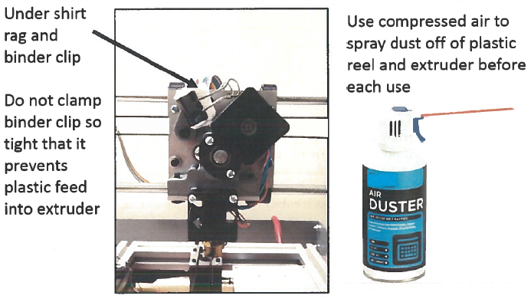**Solutions to Minimize Damage from Dust**

Under Shirt rag and binder clip

Use compressed air to spray dust off of plastic reel and extruder before each use

Do not clamp binder clip so tight that it prevents plastic feed into extruder

One other easy inexpensive preventive maintenance activity is to cover the 3D printer with a plastic garbage bag while it is not in use. Covering the 3D printer while it is not in use will greatly reduce the amount of dust that can accumulate on the machine and/or the plastic reel.

It is also important to store the unused plastic filament in a large plastic tote with a lid or in a garbage bag. Preventing dust build up on the feedstock materials while they are in storage will minimize the potential problems that dust will cause the 3D printer. This will greatly extend the life of the hotend on your extruder. I have found that without dust prevention, a hotend will use between 5-10lbs of plastic before getting clogged and needing replacement with proper dust prevention techniques, the nozzle will be able to handle 30+ lbs. of plastic before needing replacement. That extends the life of your equipment over three times!

Another factor that can clog nozzles is the quality of the plastic filament that is used. Just because you were able to get a low price in buying a lot of plastic from an unknown manufacturer does not mean that you got a good deal. Plastic filament can contain many particles inside the plastic that you can't see on the surface. These particles can also collect on the inside of the nozzle and cause clogging issues. When purchasing plastic filament for a 3D printer, paying a little extra for a high­quality product can save lots of money in the long run. Plus, the 3D printer will produce better looking, higher quality printed parts.

**Ongoing flexMendel Maintenance**

3D printer maintenance is an important topic when working with 3D printers. Many people believe that when they purchase a 3D printer it should work perfectly, right out of the box and they will never have to perform any types of maintenance activities. This is not true. A 3D printer is a machine and has many moving parts. There are a number of motors, gears, and belts that are constantly in motion and heating elements that will eventually need replacement. You wouldn't be able to drive an automobile for very long if you did not perform any type of regular maintenance on the machine. Periodically you have the oil changed, tires rotated, fluids and brakes checked, etc. Most people do not do their own maintenance on their automobile but recognize that it is an essential part of owning a car. This is true for almost any type of machine that has moving parts. 3D printers are not excluded from requiring maintenance. The maintenance required on a 3D printer is going to highly depend on the quality of the machine and the type of environment the machine is housed in. The quality of the automation components and the number of 3D printed parts on the machine also play a role in maintenance activities. Below is a list of common maintenance activities for 3D printers:

1. Replacing the nozzle and hotend components
2. timing belts if they become frayed
3. Adjust/ tighten bolts
4. Replacing 3D printed parts if they break
5. Re-calibrating the 3D printer
6. *Replacing the Nozzle and Hotend Components* -

Replacing a nozzle or other hotend components is probably the most common form of maintenance that will need to be performed on a 3D printer. When a nozzle gets clogged with dust and/ or dirt, it prevents molten plastic from flowing through the orifice at the tip of the nozzle. This causes plastic to backflow into the hotend and seep out the threads of the nozzle or even up into the entry hole for the plastic. Brand new nozzles can last anywhere from a week to a year depending greatly on the amount of time the machine is in operation and what types of preventative maintenance precautions have been taken. The number one cause of cause of a clogged nozzle is dust. There a number of preventative maintenance activities that can be performed to mitigate dust from entering into the hotend (please see the preventative maintenance section for tips).

There are a few important items that need careful consideration when replacing a nozzle or a hotend. There are dozens of types of hotends available on the market today of varying qualities. When replacing a hotend, please follow the manufacturer's instructions that pertain to that particular hotend. One good aspect about most open source and commercial 3D printers is that they use a hotend that has a common size for mounting the component to the extruder.

When replacing a nozzle you need to check the orifice size on the nozzle and decide if you want to continue to use the same size. If you choose a different size orifice, make sure to update that change in your Slic3r settings. The next thing that requires careful consideration is the type of thermistor that will be used on your new hotend. Try to find the same type of thermistor you have on your existing hotend. If you switch hotends, you might have a new type of thermistor that needs to be accounted for in the firmware of your 3D printer. It is easy to update the type of thermistor in the firmware. Simply open the Arduino Firmware file that came with the 3D printer, go to the "Configuration.h" tab and scroll down until you find the "Thermal Settings". It will look something like this:

//==========================================================

//====================Thermal Settings ====================

//==========================================================

//// Temperature sensor settings:

// -2 is thermocouple with MAX6675 (only for sensor 0)

// -1 is thermocouple with AD595

// 0 is not used

// 1 is 100k thermistor

// 2 is 200k thermistor

// 3 is mendel-parts thermistor

// 4 is 10k thermistor !!do not use it for a hotend. It gives

// bad resolution at high temp.!!

// 5 is ParCan supplied 104GT-2 100k

// 6 is EPCOS 100k

// 7 is 100k Honeywell thermistor 135-104LAG-J01

#define TEMP_SENSOR_0 1 //use 5 for JHead

#define TEMP_SENSOR_1 0

#define TEMP_SENSOR_2 0

#define TEMP_SENSOR_BED 1

Find the new type of thermistor that you are going to use in the list and insert the code number (the number at the beginning of the line where your thermistor is) and replace the code number in TEMP_SENSOR _O to reflect the change in thermistor. You will then need to flash the updated firmware into the 3D printer controller before printing.

1. *Timing Belts -*

The replacement of the timing belts on a 3D printer are going to depend greatly on how much the 3D printer is used, the belt tension, and whether or not the belts are aligned properly. Timing belts will need to be replaced if you notice that the belt is starting to fray from excessive rubbing on other components. If belts are over tightened, they can stretch to the point where the metal wires are exposed from inside belt. If you can see the metal wires in areas where the belts were stretched too far then you will need to replace the belts. It is a fairly easy process that usually requires the loosening of several screws on the respective motor or idler pulley to remove the belt. Make sure that when changing the belts that you replace it with the exact size as the belt you took off the machine. There are lots of belt that have different lengths and gear tooth spacing. Be cognitive of these details when ordering new belts.

1. *Adjusting and/or Tighten Bolts -*

3D printers move when they create 3D printed parts. Sometimes they vibrate really fast depending on the particular features of the part being created. During this process it is not unheard of for bolts and screws to come loose and start to make rattling noises when the machine is in operation. If you notice a weird noise of something vibrating when the 3D printer is making something, chances are that a bolt came lose and is rattling. You can easily check the different bolts on your machine to see which ones might be rattling. First, use your hearing to try and locate the general location that the sound is corning from. You should be able to recognize if the rattling is coming from the front, back left or right of the machine. Then after you have located the general location of the noise, you can simply place your finger on the different bolts in this region to see if the noise stops when you touch them. If you locate a bolt or screw that has come loose, simply tighten the screw and check to see if that has fixed the noise problem.

1. *Replacing 3D Printed Parts -*

Many 3D printers on the market today contain lots of parts that we created using other 3D printers. Plastic has certain material properties that are not ideal for constant stress or pressure. They have a tendency to warp or "creep" over time depending on how much stress is applied to the part. It is a good idea to print replacement parts for your 3D printer that are under constant stress from the act of printing. These could include plastic parts that hold the motors, idler pulleys, and even the gears on the extruder. Printing off replacement parts for your 3D printer before they start to creep is a smart idea. If the plastic parts warp so much that the 3D printer is inoperable, then it will be difficult to get replacement parts if you do not have any backups.

Carefully inspect your 3D printer and locate the 3D printed parts that are under constant stress. Obtain the STL files of those parts and print a backup set to keep on hand. This way when the plastic parts start to creep, you can easily replace them with the new parts and continue printing without weeks of waiting for new parts to arrive.

*** The flexMendel has custom-made aluminum parts that handle most of the high tension and force with the 3D printer, so you should not have to replace 3D printed parts. ***

1. Re-calibrating the 3D printer -

Occasionally you will want to re-calibrate the various axis on the 3D printer. You can easily do this with some basic tools and a precise measuring device. Depending on the mechanical setup of your 3D printer, the calibration process may be different than the procedures outlined below, but it won't be terribly different. You can always check the manufacturer’s assembly guide for calibration instructions if you are unfamiliar with this type of procedure.

# Pre-Printing Check List

Here's a quick check list to remind you how to get the flexMendel ready for 3D printing:

1. Turn on Printer
2. Clean the bedplate:
   1. Use the razor scraper to scrape away any plastic stuck to the glass
   2. Use a microfiber cloth to perform a final buff on the glass to remove any finger prints
3. Home the flexMendel
   1. Z-height
   2. Perform quick bed-leveling exercise
4. Check filament from the reel to the extruder
   1. sure there are no tangles in the reel
   2. Remove excess plastic from the bed and tip of the nozzle
   3. BE CAREFUL NOT TO DAMAGE THE NOZZLE!
5. Load the G-Code file onto the SD card and insert into the SMART Controller
6. The flexMendel is now be ready for printing

# Slic3r Introduction

Introduction and Background

One critical part of the 3D printing process is having the ability to create a G-code file of the three­dimensional object to be printed. Here is a quick review of the file conversion process. 3D models to be manufactured with a 3D printer are created using a variety of different 3D CAD software programs or by using digital scanners. Those 3D model files are then exported into an ambiguous CAD file, most commonly STL files. STL files are the input files required for the G-code file conversion process. It is the G-code file that contains all of the necessary information, including motion and temperature commands, for the 3D printer to manufacture the 3D object. The software programs used to convert the G-code files are also known as G-code generators.

1. Introduction:

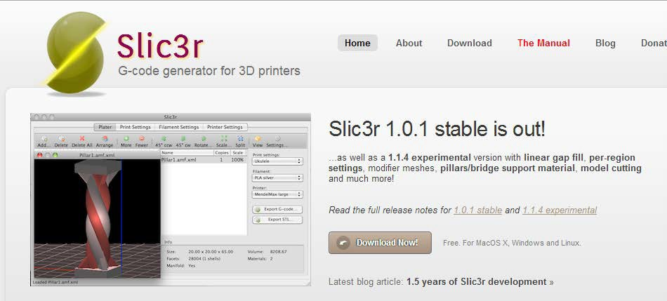

“**Slic3r**”, an open-source G-code file generator, has proven to be one of the most significant contributions to the Open Source Maker Movement. It has helped hundreds of thousands of people from all over the world create G-code files for millions of 3D printed objects. Its impact in the 3D printing industry has been profound, and the contributor deserves to be recognized.

Alessandro Ranellucci, the originator of the Slic3r project, released the program to the open­ source community in 2011. Since then, hundreds of people have collaborated on the software, increasing functionality and improving the algorithm so that 3D printers can create higher quality parts. Slic3r is a well-known staple in the RepRap community and is utilized on many open­source and commercial 3D printers. This guide is designed for educators who have incorporated 3D printing into their classrooms and want basic instruction on Slic3r's capabilities. If there are any questions that are unanswered by this guide, there are several complete manuals that are published free on the Internet.

Getting Started: Download and Install Slic3r

1. Please visit the webpage, http://www.slic3r.org/download, for software downloads.



Option 1 is the easiest method for downloading and installing Slic3r. Simply select the type of operating system that you will be installing Slic3r on, and it brings you to an online file repository where the installation files are.

One important thing to note about the program installation files is that there are usually two types of files posted on this page. One is the current, fully functional, tested version that is labeled “stable”. The other version, “experimental”, is the current work-in-progress that is being developed by Beta testers before being released as a stable version. It is not recommended to download the experimental version unless you know exactly what you are doing.

For Mac Users:

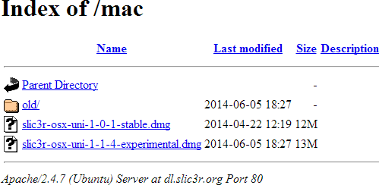

For Windows Users:

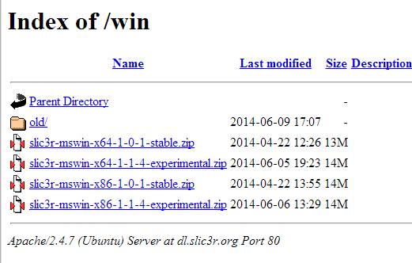

Select depending on whether you have a 64-bit or 32-bit processor

For Linux Users:

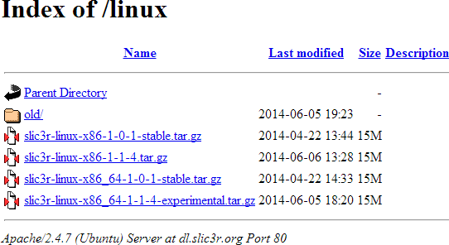

Unzip the master folder by right clicking on it select “Extract All”. Find a place to store the unzipped master folder. Remember where you store the master file as you may need to reference it in the future as newer versions of Slic3r become available and to access various config files you may create. You can create a shortcut for the program for ease of use and place the shortcut somewhere that is easily accessible. You can delete the zipped or compressed folder from your computer as it is no longer needed.

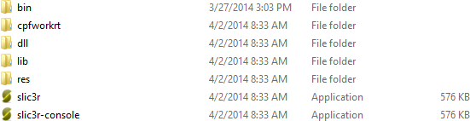

**\*Note**: If you have purchased a commercial 3D printer that recommends using Slic3r as the G-code generator, they probably have supplied you with the proper “config file” specific for that model of 3D printer or they have it available for download on their website. Please find the appropriate config file and follow the directions for “Load Config File” below.

Click on the main Slic3r icon to open the program. The first thing that will pop up is the “Configuration Wizard”. This wizard is streamlined to enter in the bare minimum configurations that can get you printing fast. In this manual we will be using an open source 3D printer called the “flexMendel” in the configuration process. Your 3D printer will most likely have different specifications that need to be entered into the respective sections. Make sure that you have the machine specifications on hand when going through this process.

Before using the 3D printer for the first time, you should make sure of a few things that can greatly affect print quality. Make sure that the bed is completely level. The average layer height that 3D printers create is 0.3 mm. If the print bed is 200 mm x 200 mm, getting the entire print area to be level within 0.3 mm will take a bit of practice. You should go through the "Bed Leveling Exercise" every time before printing something to ensure that the first layer of the part will adhere to the bedplate as intended. With a little practice, you will be able to level the bed as naturally as riding a bike.

Getting Started: Turn on "Expert Mode"

This will give you much more functionality with this program. This guide will describe many of the various settings and suggest which items are used most often.

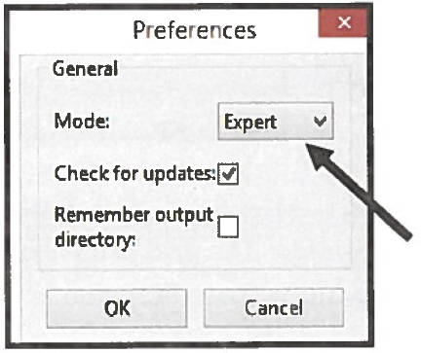

1. Open Slic3r.
2. Go to FILE > Preferences.
3. Change Mode to "Expert."
4. Restart Slic3r for changes to take effect.
5. You now have full control of the software settings.

Getting Started: Loading a "Config File"

If you have purchased a 3D printer that recommends using Slic3r, they have probably supplied you with a config file that contains all of the proper settings for that specific 3D printer. Loading a config file is easy:

1. Locate or download the appropriate config file for your 3D printer.
2. Create a new folder inside the master file for Slic3r, and title it "Config Files."
3. Place the default config file in the new folder.
4. Open Slic3r.
5. Go to FILE > Load Config.
6. Find the default config file for your printer, and select Open.

All of the manufacturers recommended Slic3r settings should now be loaded in Slic3r.

* Note: The following default config file settings are for an open-source 3D printer called the flexMendel (http://www.thingiverse.com/thing:251227). The settings are only to serve as suggested default settings that are applicable to a majority of 3D printing needs. When you gain experience using your own 3D printer and learn how Slic3r settings affect your 3D printed parts, your personal preferences may differ from the settings utilized in the following example.

Slic3r Setting Descriptions: Plater Tab

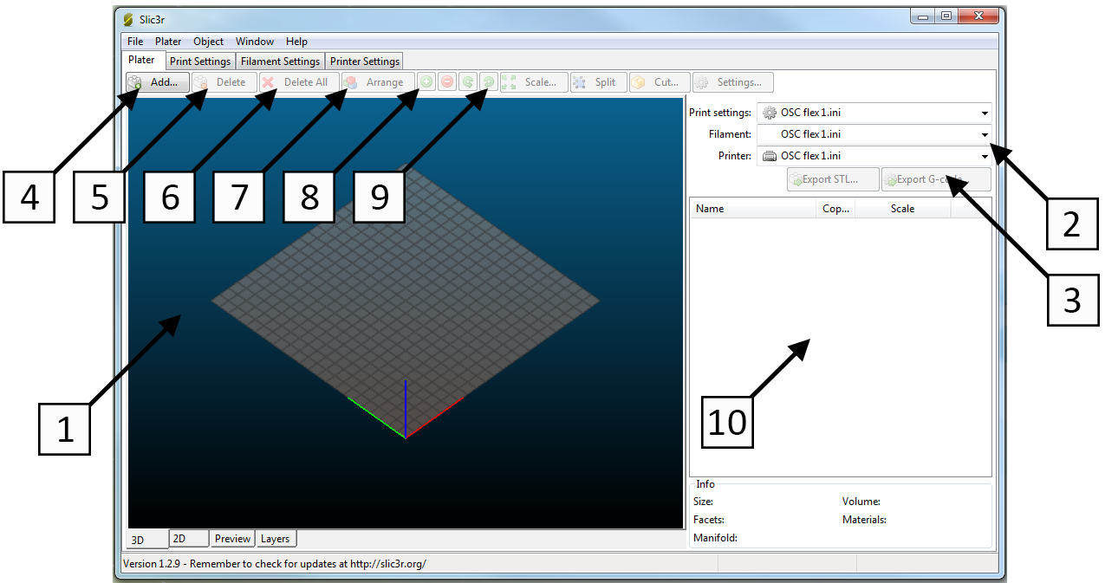

1. *Plater - AKA* the digital print bed. Shows a birds-eye view of the location of the STL files to be printed. The grid is measured by 10 mm for each line to give you a visual reference of how much space is available when adding parts to be printed.

1. *Quick view of the preloaded Config Files* - You can easily change the config files with the drop­down menus. This can be helpful if you have several config files saved with different settings depending on the printing application. Creating multiple config files that can quickly be loaded for different types of printing applications is explained with more detail in Section 6, Concept vs. Quality.
2. *Export G-code and Export STL* - These buttons are used to create either G-code or new STL files after you have loaded the STL part files you wish to print. The "Export G-code" button creates the file to be sent to the 3D printer for printing. The "Export STL" button can be used to create a new STL file that contains multiple files on a single print plate, which can ease file sharing, If several parts are made to be printed together, you can combine them into a single STL file.
3. *Add* -There are two ways to add STL files to the platter. If you click the "Add" button, a file open box will appear where you will select the file to be added. You can also simply drag­ and-drop the STL file directly onto the digital platter.
4. *Delete* - This button will delete a single STL file that is highlighted in red on the platter and highlighted in the STL file list.
5. *Delete All* - This button will delete all STL files that have been loaded onto the platter.
6. *Arrange* - This button is used to auto-arrange the STL files on the platter. Slic3r generates the machine travel paths based on an algorithm that aims to minimize machine travel, but it is not always perfect. It is good practice to evenly space out the parts on the platter before creating the G-code file. To learn more about optimum STL file placement, see the "STL File Arrangement" section of this guide.
7. *Plus and Minus* - The plus and minus buttons will add or subtract the number of copies of a particular STL file on the platter to print multiple copies of a part. However, this function is not optimal because Slic3r will treat the extra "copies" of the STL file as one STL file and not keep them separate when creating the parts. So, if you load one STL file onto the platter and create several copies, Slic3r will draw all of the perimeters first and then go back to each part for the infill, which could cause problems. If printing several copies of the same part, it is better to load them as separate files. Then, Slic3r will complete the entire layer of a part before moving onto the next part. This reduces machine travel and also reduces the chances of plastic being dripped onto the parts because it has to move back and forth so much throughout the print.
8. *Rotate* – The rotate buttons are great for moving STL files around to help them fit on the platter more efficiently.
9. *STL Files Loaded Box* - This box shows all of the STL files loaded onto the platter. Keep in mind that Slic3r will create machine travel information based on the order that the parts are listed in this box. So, the first file in this box will be the first file that the 3D printer will start making. This is also one aspect that is covered with more detail in the "STL File Arrangement" section.
10. *Scale* - This button provides the ability to scale the selected STL file to larger or smaller sizes based on the desired percentage input. Be careful when scaling models to bigger sizes because you may accidentally scale the STL file larger than the maximum printable area available for the 3D printer.
11. *Split* - This button can be used if multiple parts come on a single STL file so that you can "split" them into separate files. This is handy if you find a project on thingiverse.com that provided multiple parts on a single STL file, but you want to separate them to print the parts in different colors.
12. 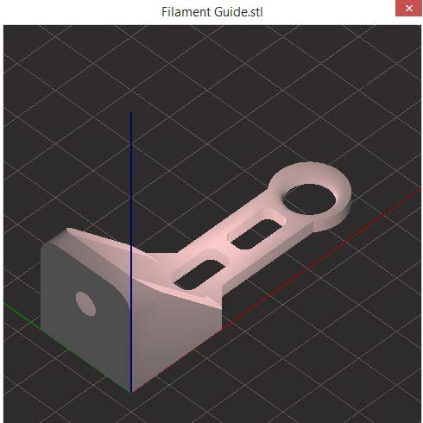*View* - The 3D viewing button, a newly added feature to Slic3r, lets you see a quick 3D view of the STL file selected to inspect whether you may need to add support material or include other 3D printing options.
13. *Settings* – This button give the user advanced control of individual STL files to be printed. For example, you can use this feature to add support material to one STL file but not others on the platter. Also, if using a dual-head extruder, you can assign different materials to different parts with this settings menu.

Slic3r Setting Descriptions: b.) Print Settings Tab – Layers and Perimeters



1. *Layer Height* – This section controls the height of each layer of the printed part. Slic3r will not let you set a layer height that is larger than the orifice on your nozzle. For example, if the orifice of the nozzle is 0.4mm, then 0.4mm is the maximum layer height that is allowed.

There is an inverse relationship between overall printing speed and part resolution when changing this setting. The larger the layer height, the quicker the part will be created on the 3D printer with reduced resolution. Inversely, if you reduce the layer height the part will have higher resolution but take longer to create. For example, if a part is printed with the normal default settings above, it will come out with a resolution of about 300 microns (0.3mm layer height). If you reduced the layer height to 0.1mm (100 micron resolution) then it will take about three times as long to print. In most cases, the difference is negligible.

You do have the ability to change the height of the first layer which is a good function because you can reduce subsequent layer heights while keeping the first layer at the normal height. If you think leveling the bed to be within 0.3mm is tough, try leveling it to be within 0.1mm!

1. *Vertical Shells* – Vertical shells are the number of perimeters that will be drawn with each new layer. This gives the part the respective number of solid layers on all vertical surfaces.
2. *Horizontal Shells* – Similar to vertical shells, this setting changes the number of solid layers on all horizontal surfaces of the part. Anywhere the part has a horizontal surface, either on the top or bottom side, this setting will generate a respective amount of solid layers on those surface features.
3. *Quality* – The boxes checked in this section are to help Slic3r detect features with the part that is going to be printed that usually require extra material in order to improve the overall quality of the finished product. When learning about how 3D printers manufacture parts, you will notice that not all features on a printed part are created equally. These settings will help detect features on a part that normally would not print very well and Slic3r will add extra material in specific areas of the part to reduce the potential for defects. This is an amazing feature of Slic3r!
4. *Advanced* – The advanced settings allow you to randomize the starting points for each new layer and change whether you want to print the inner or outer perimeter layers first. Each time there is a starting point on a layer there is the potential for a minor imperfection on the outer surface of the part. Randomizing the starting points reduces this side effect from being noticed.

Slic3r Setting Descriptions: b.) Print Settings Tab – Infill



1. *Infill* – This setting you will probably change quite often. The density setting determines the percentage of material that will be extruded on the inside of the part. In general, 25% or 0.25 will satisfy most printing needs. It also will affect the amount of time it takes to produce a part. If you have a class full of students that all want to use the 3D printer, you can reduce the infill percentage to greatly reduce total printing time.

Slic3r also has several different patterns of how it will create infill. Rectilinear fill patterns for all layers, (top, bottom, and inside) is the most common setting.

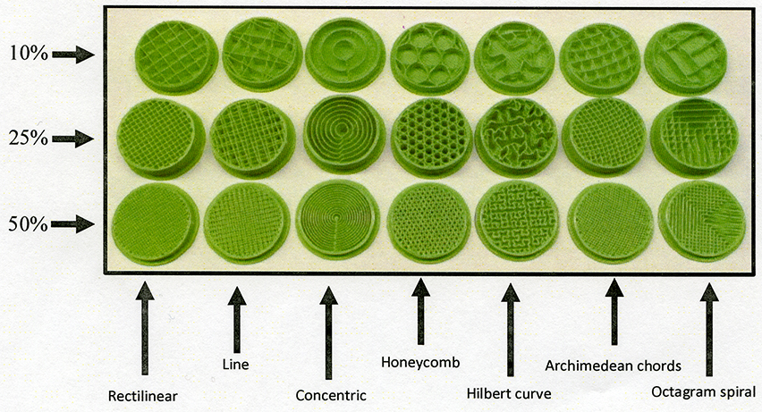

Various infill patterns and percentages

1. *Reducing printing time* – This setting allows the user to enter in the number times that infill should be generated inside the part. To save overall printing time, you have the ability to increase this number. For example, if you raise the “Combine infill every layers” to 2, then Slic3r will only generate infill every other layer. This will sacrifice some overall quality of the part but the tradeoff is that the 3D printer will create the part almost twice as fast.
2. *Advanced* – Slic3r will allow the user to combine lower percentage infill layers with solid layers inside the part using this setting. Sometimes it might make sense to generate a solid layer every 10 or 20 layers to give the part more structural integrity without having to print the entire part solid.

You can also change the “fill angle”. The default setting is 45⁰ to give the part a crisscross pattern inside the part. It may make sense to change this setting if you have a long part that will only fit on the platter diagonally. If the part is on the platter at a 45⁰ angle, you can change the infill angle to be 0⁰. The final result will have the 3D printed part contain infill at 45⁰.

The solid threshold setting will detect features of the part that are smaller than given area in this setting and create them using solid infill.

Slic3r Setting Descriptions: b.) Print Settings Tab – Speed

The “Speed” tab truly gives the user an enormous amount of control of their 3D printer when generating a G-code file. Not every section will be explained in detail here, but it should be noted that when watching your 3D printer, if you notice certain times when the 3D printer is having difficulties while in motion, you can easily change the speed settings here. As with most types of manufacturing, speed and quality are inversely related. If poor print quality is noticed during a particular type of 3D printer movement, then it makes sense to alter the speed settings. Lowering the speed settings will reduce the chances for poor output quality.



1. *Speed for print moves* – In general, the perimeter speed settings are slower than the infill settings because you won’t be able to see the inside of the part when it is completed. It does not have to be perfect on the inside. Support material is set to a speed that is even faster still because it will be removed from the part entirely upon completion and quality is of minimal importance.
2. *Speed for non-print moves* – This setting should really depend on the quality of your 3D printer. Lower quality printers that do not have a sturdy frame may not be able to handle quicker travel speeds without shaking the machine.
3. *Modifiers* – The first layer is critical to get a good adhesion from the plastic onto the bedplate. Slowing down the first layer speed greatly increases the plastics ability to stick to the bedplate. The “modifier” changes all of the settings in the “Speed for print moves” by the percentage that is entered into this box. In this example, the first layer will operate at 35% of all settings depicted above.
4. *Acceleration control* – This section allows the user to change the acceleration control speeds of the various machine moves. Acceleration control is the 3D printer’s ability to anticipate changes in speed and direction of the motors and can be adjusted if necessary. I have never changed these settings.

Slic3r Setting Descriptions: b.) Print Settings Tab – Skirt and Brim



1. *Skirt* – The skirt is an important part of 3D printing even though it is not connected to the part at all. The skirt is the first bead of plastic extruded on the bedplate which circles the outer perimeter of all parts on the platter at a specified distance.

There are two main functions of the skirt:

1. To give the 3D printer time to purge any air bubbles that may have entered the nozzle during the preheating stage. When the nozzle heats up, plastic tends to drip out of the bottom, thus creating a void of material in the barrel. The skirt allows the extruder time to fill back up with plastic so that when it starts creating the printed part. Therefore the barrel will be full of material when it begins the part.
2. The skirt also gives the operator the ability to visually check to see if the bed is level. Watching the bead of plastic that is extruded with the skirt can alert the operator if the bed is not level or if the Z-height needs any minor adjustments. If the Z height is too low and the tip of the nozzle is pressed against the bedplate, it will prevent the hot plastic from being extruded through the orifice. The molten plastic then builds pressure inside the barrel and forcing the material to flow backwards down the threads of the nozzle or up into the extruder. Both of those cases are bad news and can cause damage to the hotend or the extruder.
3. *Brim* – If you are having difficulties getting the first layer of a particular part to stick to the bedplate, then adding a “Brim” to the part could help solve the problem. This setting will create a brim at the specified distance all the way around the part during the first layer. It will have to be cut off of the part when completed.

Slic3r Setting Descriptions: b.) Printer Settings Tab – Support Material



1. *Support material* – Before printing a part with your 3D printer, it is good practice to visually inspect the digital file and look for features that might be problematic while printing. If the part is irregular shaped or has no flat bottom that will attach securely to the bedplate, then you will want to generate support material during printing. By checking the “Generate support material” box, Slic3r will generate support material for every feature that it detects an overhang threshold of 45⁰ or less from the bedplate. 3D printers can usually handle prints that contain up to a 45⁰ overhang with relatively no problems, but once the threshold becomes more horizontal, gravity starts to take over. The hot, extruded plastic starts to behave unpredictably. It will want to curl up or droop down thus creating undesirable qualities on the finished product. Support material helps to alleviate these ill effects that are present with almost any 3D printer. The down side is that when the part is complete, you will have to scrap off the support material that could also leave undesirable marks on the finished product. Support material has come a long way over the years but is still not perfect. If the ill effects on the finished product are unacceptable, then there are other solutions that could help rectify the situation.

One solution in this case it to inspect the part and see if re-orienting the part could alleviate the gross overhang. If not, there is also the possibility of creating multiple parts that could be assembled together after printing them separately with ideal orientations.

1. *Raft* – The raft feature will generate entire layers of support beneath the entire surface area of the parts to be printed. You can adjust how many layers of a raft you would like to include. This might also be necessary if there are no flat surfaces on the part to be printed that can attach securely to the bed plate.
2. *Options for support material and raft* – Slic3r gives the user a lot of control when generating various types of support material. The settings allow for the user to adjust the pattern, pattern spacing, and several other options.

Slic3r Setting Descriptions: b.) Print Settings Tab – Note

The notes sub-tab is where the user can place any personal notes about specific settings they changed in Slic3r that will show up in the beginning of the G-code file. This feature is not heavily utilized unless specific information about the G- code file needs to be recorded for future reference.

Slic3r Setting Descriptions: b.) Print Settings Tab – Output options



1. *Sequential printing* – This function is not used very much, but when printing multiple parts, the user has the ability to complete entire objects before moving onto the next one. This would assist if you did not want any plastic drips to occur between the multiple parts on the bedplate. You will need to enter the Extruder clearance information if you wish to use this feature.

Slic3r Setting Descriptions: b.) Print Settings Tab – Multiple Extruders



1. *Extruders* – Slic3r has the ability to incorporate multiple extruders. Dual-head extruders are gaining popularity in the 3D printing community and this ability to adapt to those changes is a huge bonus. Slic3r will actually allow for the addition of 10 or more extruders if you can design a 3D printer that has these capabilities.
2. *Ooze prevention* – When using multiple extruders, the 3D printer will only use one extruder at a time. The other extruders are still hot and have the tendency to leak plastic material when not in use. This feature gives you the option to have a higher retraction rate on extruders that are not currently being used.

Slic3r Setting Descriptions: b.) Print Settings Tab – Advanced



1. *Extrusion width* – The extrusion width determines the flow rate of plastic through the hotend of the extruder. You can change many different aspects of the extrusion width in this section. Plastic flows out of the extruder in an oval shape. On the top and bottom layers of printed parts there can be small gaps where there was not enough plastic to fill the void between extrusions. To minimize the gaps of plastic on both the top and bottom layers of the part and extrude more material, increase the percentage of extrusion width to force more plastic through the hotend during these layers.
2. *Flow* – This setting permits the user to reduce the amount of plastic that flows when creating a bridge feature on a part. Having less plastic flow over the bridge reduces the sagging effect that commonly happens when creating this feature with 3D printers.
3. *Other* – Threads are used to parallelize long-running tasks. Optimal threads number is slightly above the number of available cores/processors. Beware that more threads consume more memory. In the resolution section the user can specify the minimum detail resolution to simplify the input file which can speed up the time it takes to slice the STL file. This would be used if the STL file has extremely high resolution (unnecessarily high) and could simplify the model so that the slicing process would be reduced.

Slic3r Setting Descriptions: c.) Filament Settings Tab – Filament



1. *Filament* – The filament setting is where the user can change the diameter of filament they are using. This setting usually doesn’t change often as the size is a result of the type of hotend that is used on the 3D printer. 1.75mm and .3mm are the most common.
2. *Temperature* – The temperature settings allow for both first layer and other layer temperatures to be assigned. The first layer sometimes has a higher temperature assigned to increase the ability for the plastic to adhere to the bedplate on the first layer. Similar functionality for bedplate temperature. If the 3D printer you are using does not have a heated bedplate then you would enter zero (0) into both windows for the bed temperature.

Slic3r Setting Descriptions: c.) Filament Settings Tab – Cooling



1. *Enable* – This window has two boxes that control when the cooling fans are utilized.
2. *Fan settings* – Fan settings vary from 3D printer to 3D printer. 3D printer manufactures suggest varying fan speeds, others may not use a fan at all. The user has the ability to disable the fan for any number of layers in the beginning of the print.
3. *Cooling thresholds* – Cooling thresholds give the user increased ability to control printing and fan speeds based on the time it takes to print certain layers of the part. Smaller print layers take less time and these settings allow for machine speeds to be slowed down which can increase print quality.

Slic3r Setting Descriptions: d.) Printer Settings Tab – General



1. *Size and coordinates* – This section is where the user can enter the exact specifications of the mechanical limitations of their 3D printer. Bed sizes are not always square. The ability to change print center allows for rectangular shaped beds to have the center point accurately located.
2. *Firmware* – There are six different firmware options depending on what type of firmware is loaded into the controller of the 3D printer. RepRap (Marlin/Sprinter/Repetier) is the most common for open source 3D printers.
3. *Capabilities* – This allows for the user to set the number of extruders the 3D printer is equipped with.
4. *Advanced* – This feature is experimental and can assign a noise limit that if exceeded, the firmware will slow down the machine speeds. It is an attempt to mitigate excessive vibration during printing.

Slic3r Setting Descriptions: d.) Printer Settings Tab – Custom G-code



1. *Start G-code* – This box is for the user to enter any custom G-code that will be entered in the beginning of the G-code file. In this case, two commands are used: G28 to home all axis (0,0,0) and an M92 E680 command to calibrate the motor speed for the “Low-mass Extruder” (open source extruder found at: http://www.thingiverse.com/thing:61818).
2. *End G-code* – Similar to the Start G-code box, the end G-code box allows the user to put in custom G-code commands to the end of the G-code file that can add additional functionality. In this example the user has commands to terminate both heating elements. There are also machine movement commands in place to lift the nozzle away from the part by 10mm, center the extruder, and move the bedplate in the forward position. This creates a “presentation-like” effect when the machine is finished printing so the part is easily accessible. The final G-code command disables all motors on the machine to minimize power consumption when complete.

Slic3r Setting Descriptions: d.) Printer Settings Tab – Extruder 1



1. *Size* – Enter the orifice size (hole on bottom of the nozzle) here.
2. *Position* – This is only used if the 3D printer has multiple extruders. This is the offset distance between the two hotends.
3. *Retraction* – Retraction is a good feature in Slic3r. It will retract the filament after creating a layer on a part to minimize the hot plastic from dripping out the tip of the nozzle when the machine moves to the next part.
4. *Retraction when tool is disabled* – Similar to Retraction, this setting permits the user similar functionality when one of the extruders is not in use.

***Turing STL Files into a G-code File –***

This process is relatively simple. Load the desired STL files onto the digital platter in Slic3r. Notice that Slic3r automatically will re-center all files into the center of the platter. This is good because the bedplate on a 3D printer is usually most level in the exact center. Change the print settings in Slic3r to dictate how the 3D printed part will be created. When you have all the settings adjusted to how you want them, simply hit the “Export G-code” button. You will see a green progress bar moving to the right as the G-code file is being created on the bottom of Slic3r’s window. Slic3r will automatically try to place the new G-code file in the same place or folder that the STL files came from.

There is another way to generate a G-code file. Under the File menu there is an option called “Quick Slice”. This will perform the same action of creating the G-code file and placing it back in the location the STL files came from.

# Creating Your Own Config Files in Slic3r

**Concept vs. Quality - Example Slic3r Config Files**

Creating multiple config files that serve a variety of 3D printing needs in advance can save time when trying to determine what settings should be utilized for specific printed parts. The following are suggestive preconfigured settings that can be saved as separate config files for quick and easy reference. Each new config file started as the ORIGINAL DEFAULT CONFIG FILE for this particular 3D printer. If creating new config files to save for future use, be sure to always load the original config file to refresh original Slic3r settings for your 3D printer.

**How to save a config file after changing the specific print setting changes:**

1. Go to: FILE > Export Config.
2. Make sure the new config file will be placed in the folder named "Config Files."
3. Name the config file with a descriptive name for easy reference.
4. Click "Save."

**Prototype-Proof of Concept (minimum material usage)**



1. Change the "Fill density" to 0.1 or 10%. This will minimize the plastic usage inside the part but will still provide material to support the printed structure.



1. Change the Speed of the Infill to 65 mm/ s. For "prototype" and "proof of concept" prints, speed is of greater importance than overall quality because the design is still in the developmental stage. Speeding up the speed of the infill will not affect the outer perimeter of the part but will help to get the idea created faster.
2. Go to File > Export Config and save the file as: "Prototype."

**Light Strength-Functional w/out forces (dissectible frog, biology models, etc.)**



1. Change the Fill Density to "0.2" or 20% to reduce overall material usage.
2. Change the fill pattern to "Honeycomb" to provide better support for round and odd-shaped models.
3. Change the Top/bottom to "Concentric." This will give the model a somewhat more pleasing aesthetic appearance.
4. Go to File > Export Config and save the file as: "Light Strength."

**Moderate Strength-Functional w/light forces (mating parts, brackets, etc.)**



1. Change the "Vertical Shells-Perimeters" to contain 3 perimeters instead of 2. This will add an additional support layer around the exterior features of the part.



1. Change the Infill Fill density to 0.5 or 50%. This will provide much more integrity to the inside structure of the part.
2. Add a "solid" layer of infill every 10 layers. This may not seem like it would help that much, but considering that each layer is 0.3 mm, every 3 mm will be a solid layer of infill. It will add structural integrity without adding too much plastic to the finished part.
3. Go to File > Export Config and save the file as: "Moderate Strength."

**Heavy Strength-Structural w/ strong forces (printed gears, mechanisms, etc.)**



1. Change the "Vertical Shells" to contain 3 perimeters instead of 2. This will add an additional support layer around the exterior features of the part.



1. Change the Fill Density to "0.75" or 75% to increase the structural integrity of the interior.
2. Add a "solid" layer of infill every 10 layers. Again, this increases strength and reduces the chance of failure when the finished part is being used for its intended purpose.



1. Increase the Extruder temperature by 5° C. This will help the plastic bond to itself better during the manufacturing process, which creates a stronger finished product. When changing this setting, be weary of adding multiple STL files on a single plate to be printed because the increased temperature will cause the plastic to be more susceptible to dripping out of the nozzle during machine travel. If there is only one part being printed at a time, it will only drip on the interior of the part, which doesn’t cause any problems



1. OPTIONAL - Increase the "Retraction Length" by 25% (from 2 mm to 2.5 mm in this case) to help compensate for the potential extra dripping of plastic due to the increased extruder temperature.
2. Go to File > Export Config and save the file as: "High Strength."

**Solid- Machine components, rugged applications, etc.**



1. Change the "Fill Density" to 1 or 100%.
2. Go to File Export Config and save the file as: "Solid."

**Support Material- Digital art, odd shapes, no flat bottom** 

1. In the Support Material control box, check the box labeled "Generate Support Material."
2. Change the pattern spacing from 2.5 mm to 4 mm. This will help to speed up printing time and not use as much material for support.
3. Feel free to adjust any other settings that you might want with this particular config file.
4. Go to File > Export Config and save the file as: "Support - General."

**High Resolution- Very small parts with intricate details.**



1. Change the "Layer height" to 0.1 mm. Keep the First layer height at its current setting (changing this would make that layer more difficult to print). Keep in mind that when printing in High Resolution with reduce layer heights, total printing time almost triples from default settings.
2. Go to File > Export Config and save the file as: "High Resolution- General."

**Additional References:**

Slic3r Online Manual

http://manual.slic3r.org/

Detailed Information about open source 3D printing: http://illinoiscte.org/index.php/resources/3d-open-source-printing

List of open-source/free G-code generators for 3D printing and CNC milling:

http://replicat.org/generators

# Ongoing Cost Estimations

**Material Usage Estimations**

After the G-code file has been generated, the user has the ability to perform calculations from the estimated amount of material used to figure out how much the printed part will cost after it is done printing. This information can be found at the very bottom of the G-code file. To perform these cost calculations, you will need to open the G-code file using "Notepad", "Text Edit," or another simple text-based software. When you open the G-code file, you will see all of the preliminary settings that were entered into Slic3r before generating the G-code file.



To find the material usage estimation, you will need to scroll to the bottom of the G-code file. G­ code files can sometimes contain 10,000 lines of G-Code. It is a long file. One might appreciate the fact that every single line of code is a command for each movement of the 3D printer as it creates the object being printed. At the very bottom of the G-code file, you will see the custom G-code commands that were entered into Slic3r. On the very last line of code, it displays how many millimeters of filament was used to create this part, and it gives the cubic centimeters of material in parenthesis"()." See below.



To estimate the cost of the 3D printed part before sending it to the 3D printer, you can use the volume generated in the G-code and apply this simple equation to estimate the total material cost.

**Given factors:**

|  |  |
| --- | --- |
| PLA weighs about 1.3g per 1cm3 | ABS weighs about 1 gram per 1cm3 |
| PLA costs about $0.05 per gram | ABS costs about $0.06 per gram |

1. **Figure out how many grams of PLA was used**

(Total volume)* (g/ 1 cm3) = total grams

Ex: (6.6cm3) * (1.3g/ cm3) = 8.58 grams

1. **Multiply number of grams of plastic used by the cost per gram**

(Total grams)*($/ g) = Total material cost

Ex: (8.58g) * ($0.05) = $0.43

**Plastic Parts Cost Calculator**

Included on the USB drive is a "Plastic Part Cost Calculator" that was designed to help calculate the cost of materials for 3D printed parts. The formulas are already programmed into the calculator. Input the appropriate raw material and shipping costs into the top section. The Breakdown Specifics section shows smaller increments of the actual cost of the plastic. To find the cost of a plastic part after printing, weigh the part in grams, input the number in the green box and press enter. The number that appears in the yellow box is the calculated cost of the amount of plastic used for the part.



# Troubleshooting

**STL File Corruption**

Sometimes when printing a part the 3D printer may seem like it is malfunctioning and moving in unpredictable ways. It could have been printing the part perfectly fine for an hour or more and then start acting wildly. This is usually not a malfunction in the 3D printer, but is often the result of a corrupt STL file. If you have ever tried to slice a file and received an error code, then chances are high that you have a corrupt STL file.

STL files of a 3D model are based on ambiguous numbers that contain placements of points and lines in a digital, three dimensional environment. They operate on the vertex-to-vertex rule which creates the surface dimensions of a 3D object. If the STL file is corrupted, there could be missing information in the surface dimensions of the model. If this is true, there is a chance that when converting the STL file into a G-code file the algorithm could not accurately create the machine path for this particular object. If this happens, you will need to repair the STL file using a program like Autodesk NetFABB and re-export the new STL file before slicing it again. The repaired STL file should provide you with no error codes when slicing the file and it should print the new part with no problems.

**Incorrect Design Features**

Another area where people often have problems with their 3D printer is if they are trying to print an object which contains features that are extremely difficult or impossible to create using a 3D printer. This could be due to any number of factors including incorrect orientation of a part, odd shapes, gross overhangs, and tiny details that are too small for the printer to accurately create them. If having difficulties when printing an object, be sure to inspect the object and locate any features that could pose potential problems when printing. This can also be done by inspecting the part while the 3D printer is creating it. If you notice where the plastic did not create the features that were intended, you may need to make changes in the Slic3r settings or in the features of the 3D model. (See the Design Intent section of this guide for assistance ways to optimize features of the 3D model for 3D printing)

**Where to go for help**

One of the easiest ways to find a solution to a problem with 3D printers is to simply type in the question into a simple Google search. This should return thousands of possible websites that could offer a solution. Below are several online resources that provide a place for questions and answers to be posted.

**3D Printer Blogs/Forums**

http://reprap.org/wiki/Print_Troubleshooting_Pictorial_Guide

The wiki on the RepRap site provides almost all types of troubleshooting information that is related to problems with 3D printers. Here there is an extensive guide of common problems associated with 3D printers and lots of documentation about how to fix those problems.

www.3dprintingindustry.com

This website contains many news stories about 3D printing activities in the news in a variety of industries. They have tabs for education and related resources for teachers using 3D printers in their classrooms.

www.3ders.org

This website provides an extensive forum where many questions and answers about 3D printing have been posted over the past several years. There is a review section that contains product and service reviews from companies involved in 3D printing and largely encourage the online community to engage through their website with questions and comments. A good resource to for hard-to-find answers about 3D printers.

**RepRap Discussion Boards**

http://forums.reprap.org/index.php?173

The RepRap discussion boards contain many conversations from owners of 3D printers. To use this site, simply type the topic on which you would like to discover more information about in the search bar and review the related articles that are recovered from the search. There are lots of people who ask many different types of questions on this discussion board and can be a great resource for those who are searching for hard-to-find answers.

**Project Source**

If you are working on an open source project and are having difficulties with certain aspects of the project, it never hurts to reach out to the project source with your questions. Chances are that they probably encountered similar difficulties and can provide you with shortcuts to the solution or great resources to help you solve the problem. Do not be afraid to reach out to the publisher of a project.

# Safety Hazards of the flexMendel

**3D Printer Safety**

There are several hazards that the 3D printer has that you need to be aware of. While there are several safety features built into the flexMendel's design, users should become aware of the safety hazards and use caution when operating the 3D printer.

1. *Burn Hazards -*

AB with all 3D printers, the flexMendel has components that operate at very high temperatures. The small heater block on the hotend is the most dangerous because it operates at 190° C (~ 400°). Touching the heater block will burn the skin INSTANTLY! DO NOT TOUCH THE HOTEND WITH ANY PART OF YOUR BODY WHILE IT IS HOT! The bed also contains a heating element but usually only heats up to 70°. It will be warm to the touch, but shouldn't be able to burn you.

1. *Pinch Points -*

The flexMendel has moving parts including the extruder and the bedplate. These components are in motion while the flexMendel is printing. Do not place your fingers and/or hands in the travel path of these components because the flexMendel has no way of detecting whether or not something is obstructing its motion path.

1. *Glass -*

The bedplate of the flexMendel is covered with a custom-cut mirror that measures 9.75" x 9.75". This is not shatterproof glass. If the machine is not properly calibrated or if someone hits the glass with a tool, it has the potential to shatter and cause increased safety hazards. DO NOT OPERATE THE flexMendel IF THE MIRRORED GLASS HAS BEEN CRACKED OR SHATTERED. You can go to Lowe's or Ace Hardware and have them cut a new piece of mirror for replacement.

1. *Electrical Shock Hazards -*

The flexMendel comes equipped with a GCFI attached to the AC wire that plugs into the wall. Theoretically, this should disconnect the flexMendel 3D printer if any circuits short out or loose connectivity. This does not mean that it will not shock someone if they are touching exposed electrical components.

Please use caution when working with electricity. If you are performing any maintenance on the electronics of the flexMendel, make sure to unplug it from the AC outlet to prevent any shocking hazards.

The heated bed runs on 120V AC electricity and is potentially the most dangerous part of the electrical system because the wires are located below the bedplate and they are constantly in motion. DO NOT REMOVE the protective wire sheath from the wires underneath the heated bedplate as they serve to protect the wires from wear and tear from rubbing on the workbench.

Beware of liquids around the flexMendel 3D printer. The machine is NOT waterproof. If liquids are spilled on the RAMPs controller, power supply, or any other electrical connections there is a high risk of shock hazard and the potential of ruining that particular component. Please do not have liquids of any kind around the flexMendel 3D printer in order to reduce the potential of accidentally spilling liquids onto the electronics.

1. *Razor Scraper -*

The razor scraper used to clean off the bedplate is sharp and can cause lacerations to flesh if not used correctly. USE CAUTION WHEN HANDLING THE RAZOR SCRAPER.

1. *Hazardous Materials and Off-Gassing Fumes -*

If using materials other than PLA, be cognitive of the potential fumes that off-gas while printing. If not ventilated properly, these fumes can cause headaches and nausea to those people with extended exposure.

1. *WEAR SAFETY GLASSES!!!*

Your eyes are one of the most precious organs in the human body. It only takes a split second for a flying particle to damage your eyes permanently if the user neglected to wear safety glasses.

Users of the flexMendel 3D printer are encouraged to wear safety glasses at all times when using the machine or any types of projects that involve 3D printed parts, electronics, and hazardous tools.